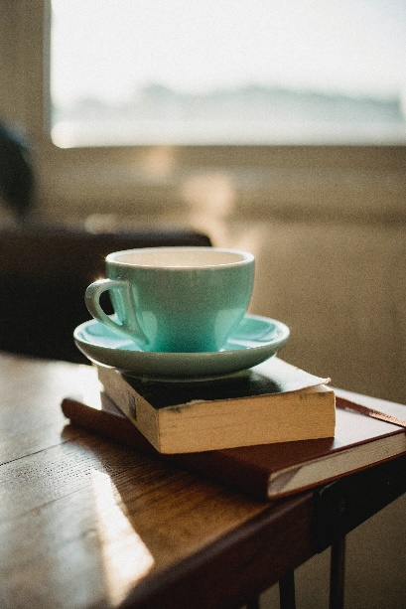White Coffee Cups – Pack of 5

Having a coffee requires a good cup, and we have our classic white cup which is great for espressos or cappucinos. It can hold up to 285ml of liquid and keeps your drink warm for a long time.

£10.00

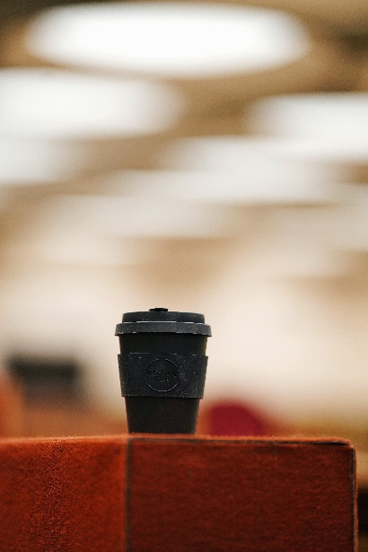

Black Reusable Coffee Cup

A good coffee cup needs to be reusable and needs to keep drinks warm for a long time, especially for those that travel or like to take their drink with them. This is our black reusable coffee cup with a lid and its dimensions are 20 x 13.5 cm. We understand the coffee lovers have different preferences for the way they drink their coffee, so we have this cup for those that like to drink on the go and want something easy to use.

£7.00

Worded Coffee Cup – Pack of 5

We know that many people have to have their typical coffee cup, so we have made our worded coffee cup which says “Choose Happy” as we know that when you drink coffee that is when you are at your happiest. It can hold up to 350ml of liquid and it is quite sturdy.

£13.00

White Coaster/Lid Coffee Mug – Pack of 5

This is our new white coffee mugs which have a green lid and coaster. This is great for those who need something simple but fashionable which protects the surface of the table and protects the mug itself. It looks aesthetically pleasing and works well with any drink and any need. It can hold up to 350ml of liquid.

£15.00

Brown Coffee Mug – Pack of 5

This is a new coloured mug that we have in the colour brown to match the wonderful coffee beans that are available to purchase. They are larger than other mugs and can hold up to 400ml of liquid.

£12.00